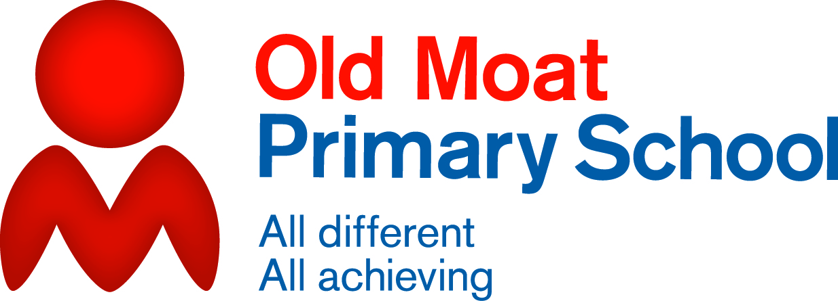
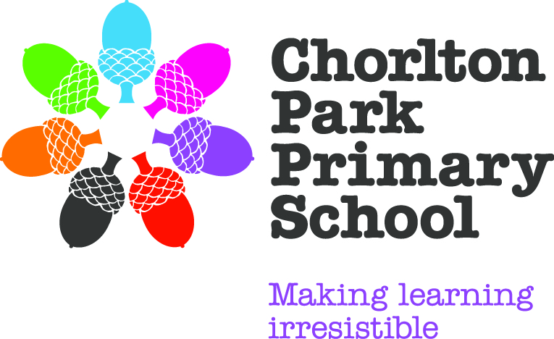

1st April, 2014

Dear Parents and Carers,
We’re at the end of another term and as promised I want to update you on the work of the governors since Christmas.
Meetings with the Heads
It was good to see some of you at our two meetings with the Head Teachers, Meryl Blackburn and Stef Habershon, the Executive Head, Dave Watson and me, Angela Keane, the Chair of Governors. We’d like to hold more of these meetings, at a variety of times, so that more of you can come along and share your views. Some of you also e-mailed questions which I’ve shared with the Heads. Here are some of the main things we discussed:
Communication: parents like the variety of communication (the newsletter, texts, e-mails, topic webs and learning logs are popular). Letters in book bags are sometimes late or lost, so these are also going to be put on the website. The website has been redesigned and we hope it’ll be an increasingly useful resource for news, homework and information. One parent raised the important issue of providing an interpreter for parents and carers whose first language isn’t English, and the Heads are following this up.
Parents’ evenings: again, parents appreciate these, but the school are going to look at the way parents get feedback from subject teachers (when children are set for maths and literacy in Key Stage 2) and up-to-date information about extra support that children may be having.
School dinners: Paul, the chef, seems to have developed a fan club amongst some of the parent body and there were lots of compliments about the quality and range of food on offer. To spread this appreciation further, the school would like to invite parents and carers to come in and try out Paul’s creations (see School Vision meeting below). You would also like menus on noticeboards to be kept up-to-date and we’re looking at putting lunchtime choices on the Parent Pay website.
Toilets: Despite the efforts of the school to keep the toilets clean and well-maintained, the age and layout of the buildings means that the only way to really improve them is to replace them. This, of course, will be expensive and the Head Teachers and governors need to explore the costs in the context of the many other expenses the school faces. In the first instance, some work is planned for the toilets close to the Reception classrooms. We’ll keep you updated on this.

Wellbeing and Behaviour
This term, some staff and governors have been looking closely at the behaviour and emotional wellbeing of the children across the Federation (in Chorlton Park and Old Moat schools) as part of our commitment to ensure that the education our children receive goes beyond their academic attainment. We’re reviewing the schools’ behaviour policy, to make sure that rewards and consequences are managed consistently. We’re looking at the support we provide when children find school life tricky, to see whether this can be enhanced. We’re exploring ways to communicate to you the skills the children acquire in school which complement, but go beyond, numeracy and literacy. The Philosophy for Children (P4C) initiative is an example of the way the schools are encouraging the children to become self-aware and to reflect on the way they relate to others – ask them about P4C and let us know what you think.
School Vision Meeting
Dave Watson has produced a leaflet which spells out the schools’ and the governors’ ambitions for Chorlton Park and Old Moat over the next few years. This vision document is a promise to the children of our schools that they will receive a high standard of education, including and extending beyond academic excellence. You’ll receive a copy of this after Easter (it will also go on the website). We’d like to invite you to come and discuss the school vision on 1st May in the early evening. To entice you further, Paul the chef will be providing refreshments. Again, there’ll be more information about this after Easter.
Have a lovely break – and I hope to see lots of you on 1st May.

Angela Keane
Federation Chair of Governors

